Level 31 -> Level 32

The goal of this level is to access **a git repository at ssh://bandit31-git@localhost/home/bandit31-git/repo.** The password for the user bandit31-git is the same as for the user bandit31. We need to clone the repository at our local computer and find the password for the next level.

This level is same as level 28,29,30.31. Follow first three steps of level 28/29/30/31.

Steps to follow after completing first three steps:

1. Check the files present in repo.
2. README.md file is present. When we cat README.md file we found a text

“This time your task is to push a file to the remote repository.

Details:

File name: key.txt

Content: ‘May I come in?’

Branch: master”

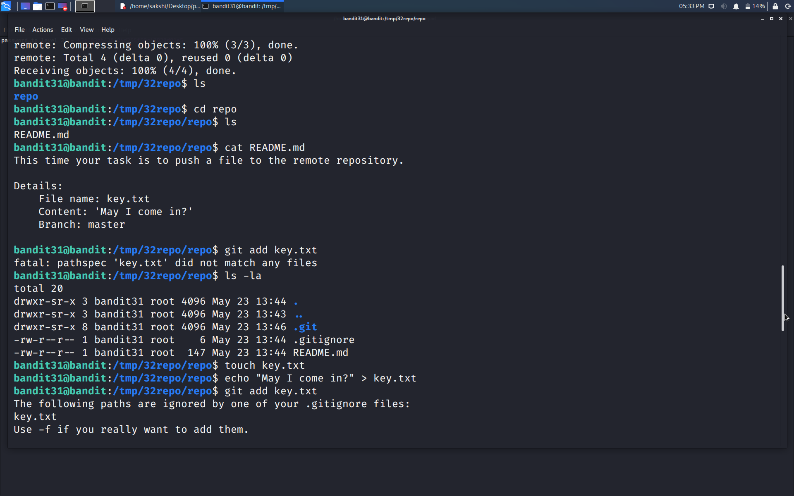

1. Hence, we need to create a key.txt file and add the line ‘May I come in?’ into this file and add this file into the remote repository. Commands used are shown in the snapshot.



1. OOPS!!! We are unable to add the file to the repository because the paths are ignored by some .gitignore file.
2. Cat .gitignore file. The .gitignore file specified intentionally untracked files to ignore. We can remove the .gitignore file first then push the file to the repository again.
3. Use command **rm .gitignore** to remove the file.
4. Now, again add the file key.txt.
5. Use command **git commit -m “My file”** to commit the change.
6. And use command **git push origin master** for branch.
7. Use the password of bandit31.

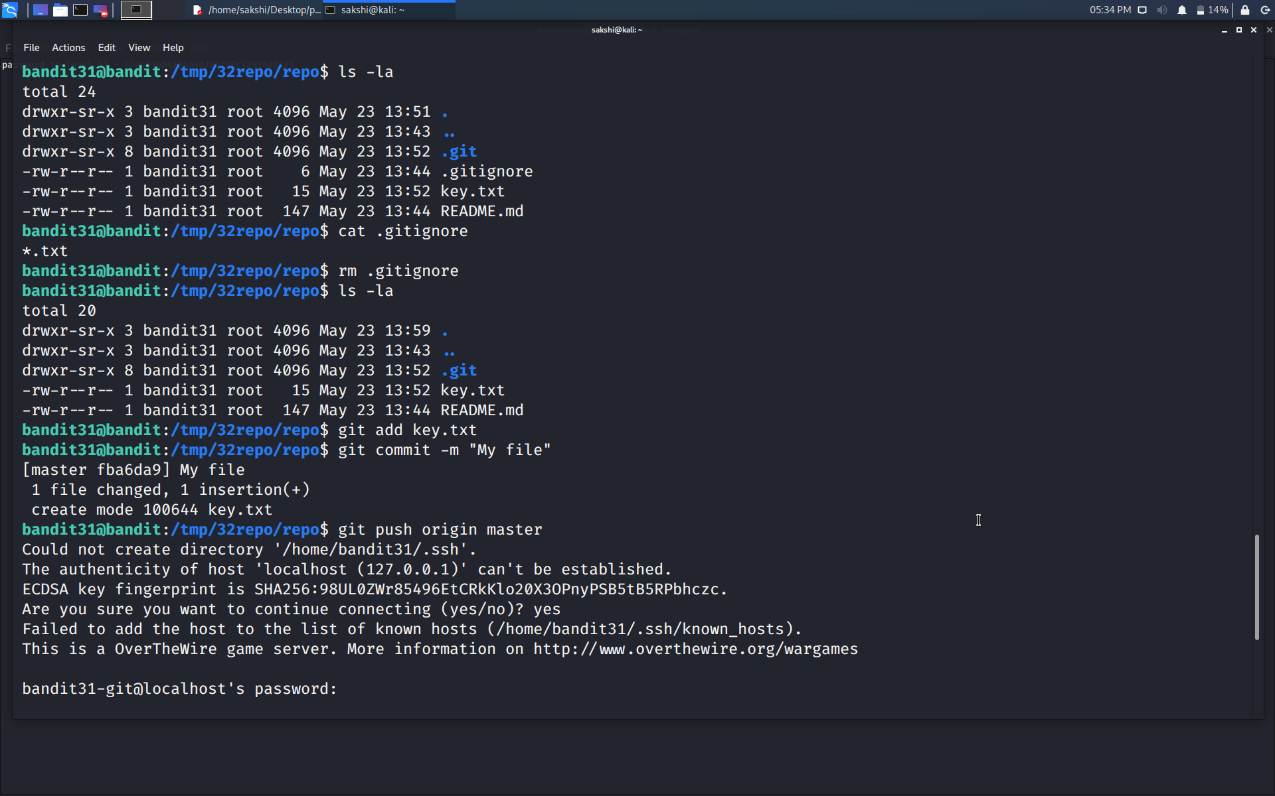

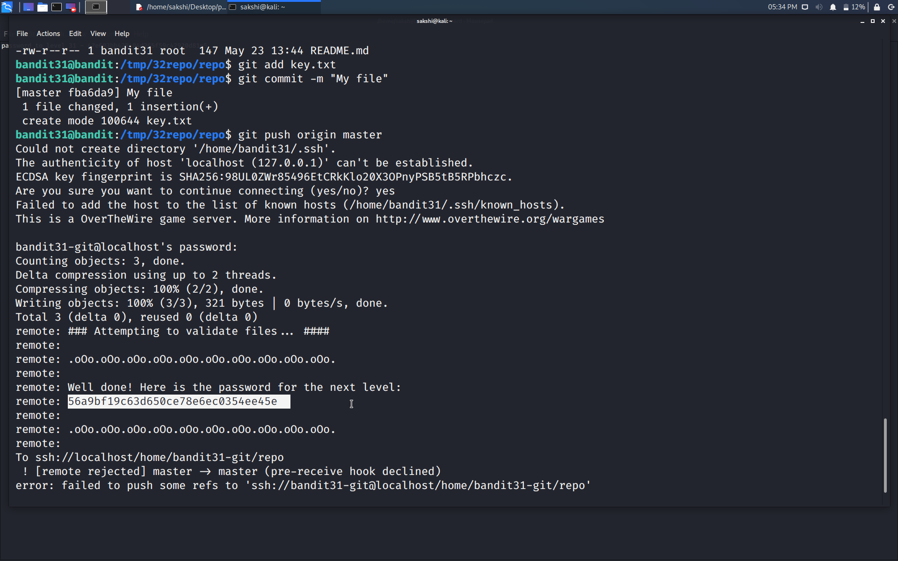

Use the command **ssh bandit32@localhost** to connect to the level 32.

Enter the password and hit enter.

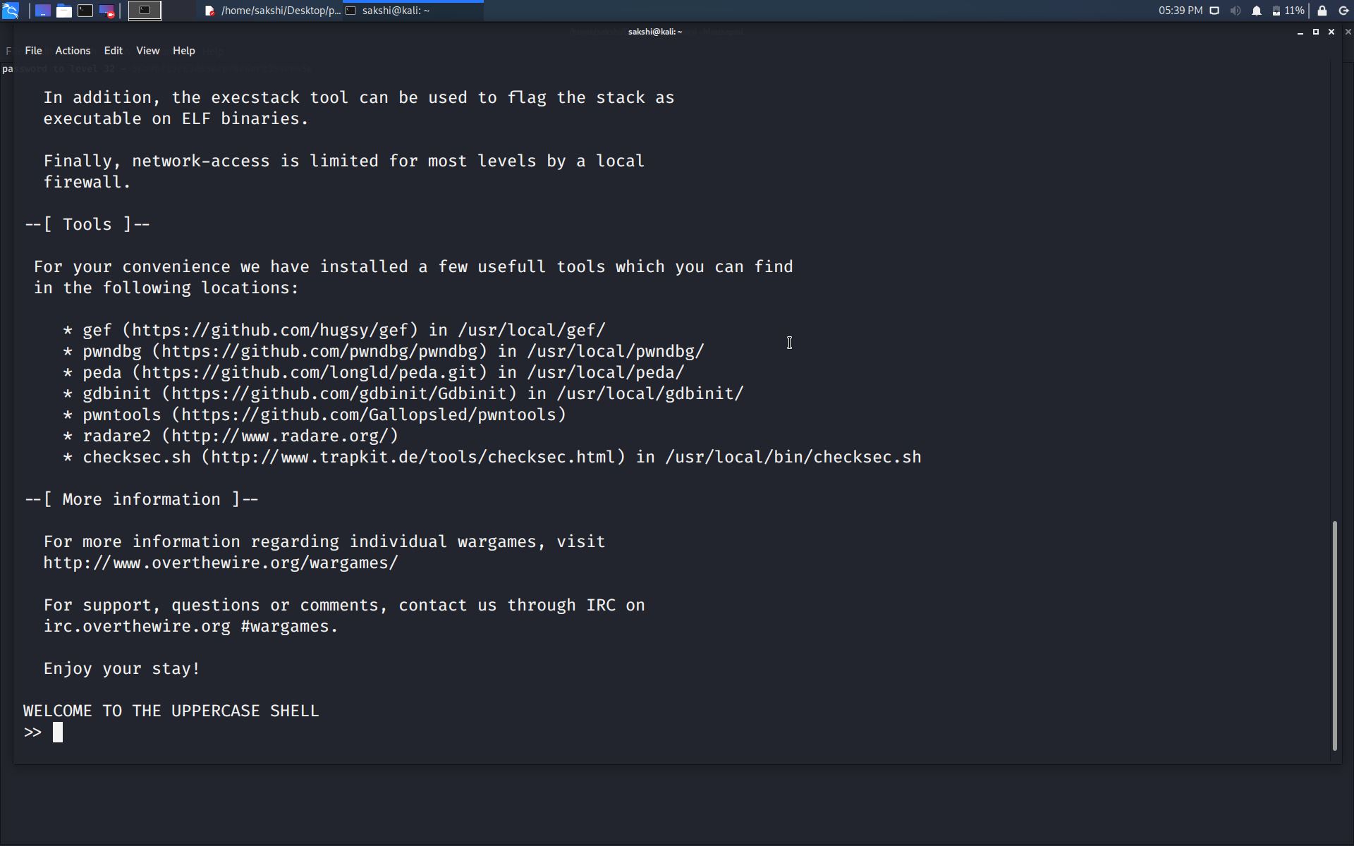

Successfully passed level 32.…